**Commands**

1. pwd: This command is used to print the path name of current working directory.

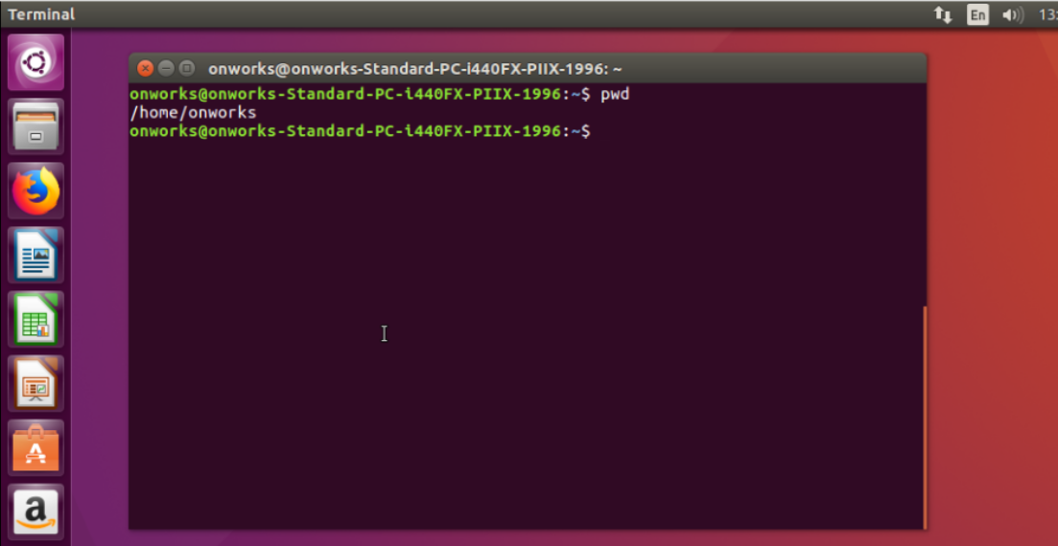

1. mkdir: This command is used to make directory. Here I have created directory as Sahana.

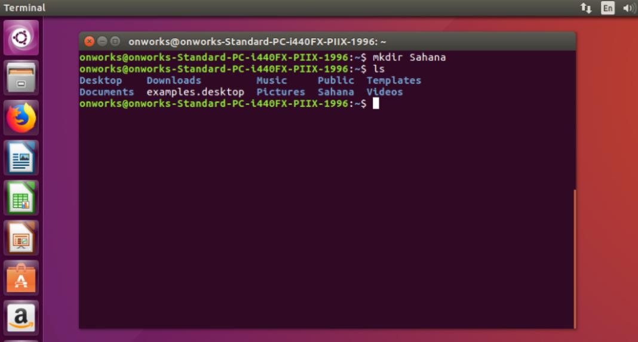

1. ls: This command is used to list the files in present working directory.

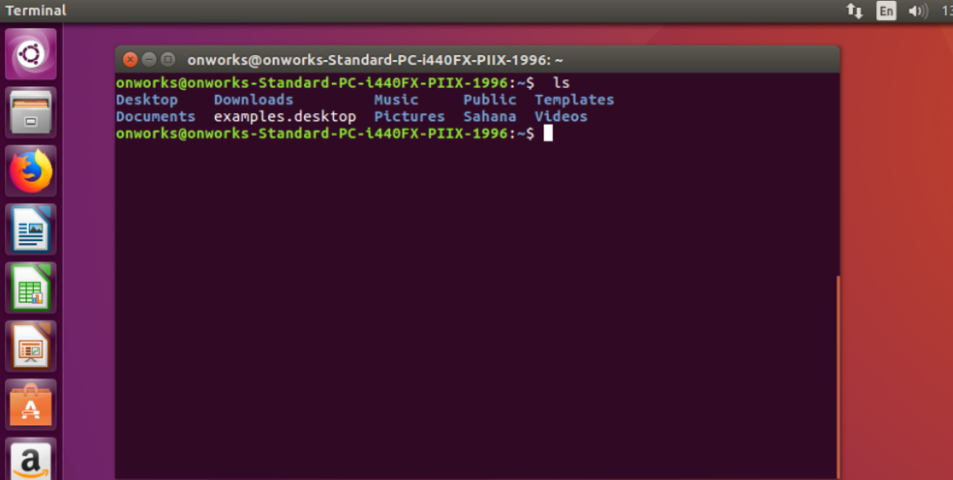

1. ls –a : This command is used to list the hidden files.

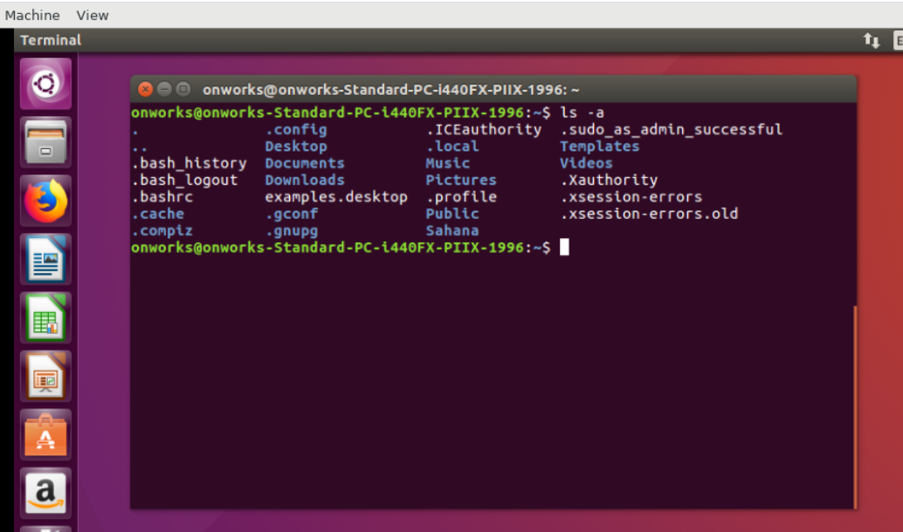

1. ls – l: This command is used to list files present in current working directory along with properties.

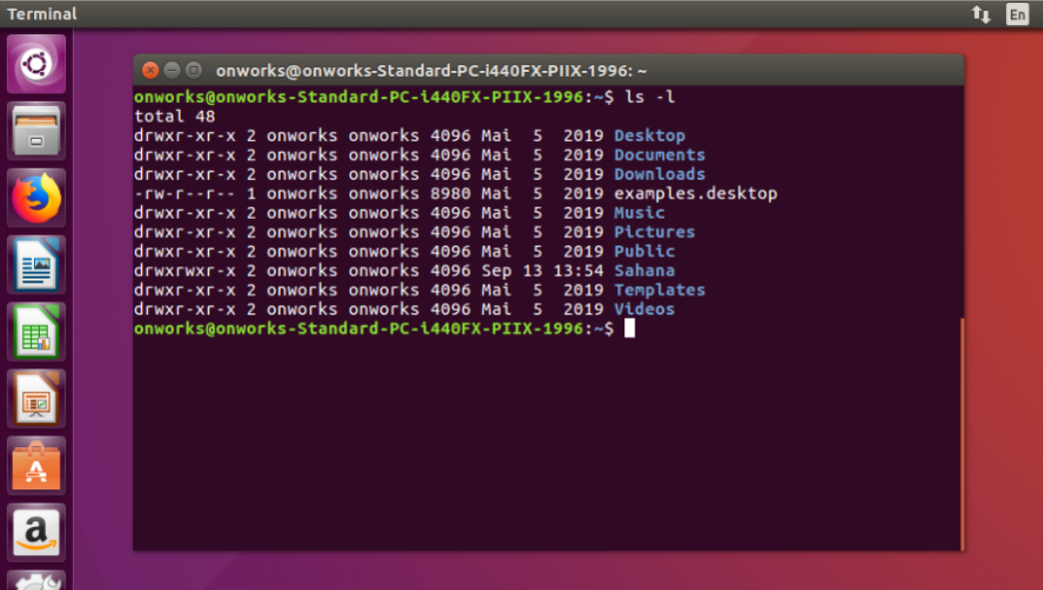

1. cd: Change directory command. This is used to change current working directory.

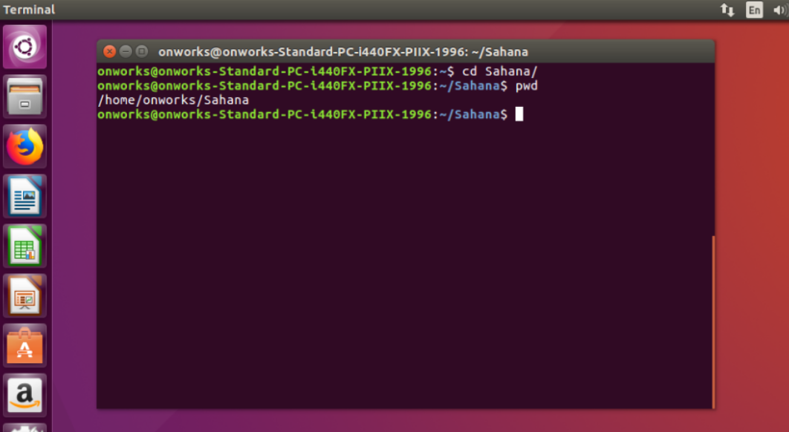

1. rm –R : This command is used to remove a directory.

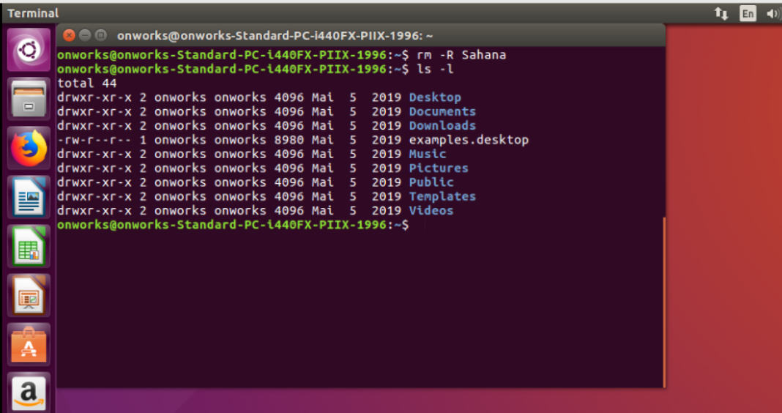

1. man: man command is used to display user manual of any command.

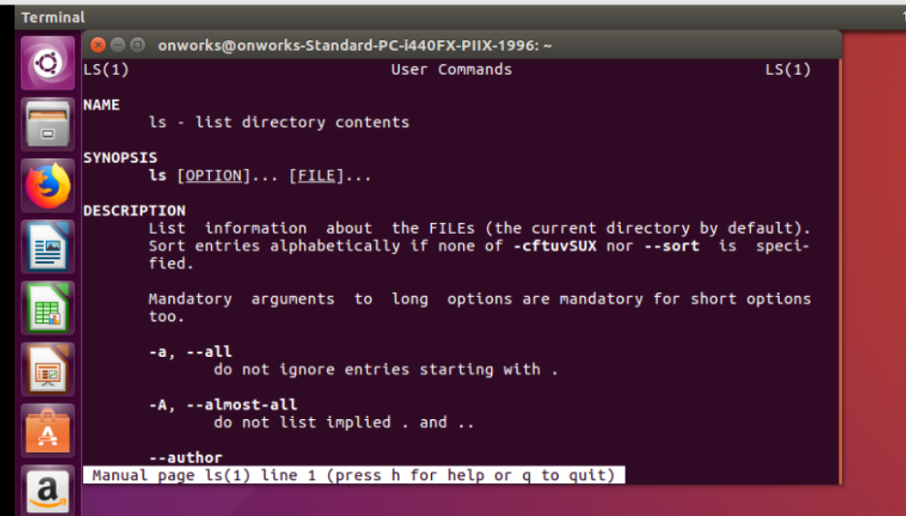

1. df: df command is used to display information related to file systems about total and available space.

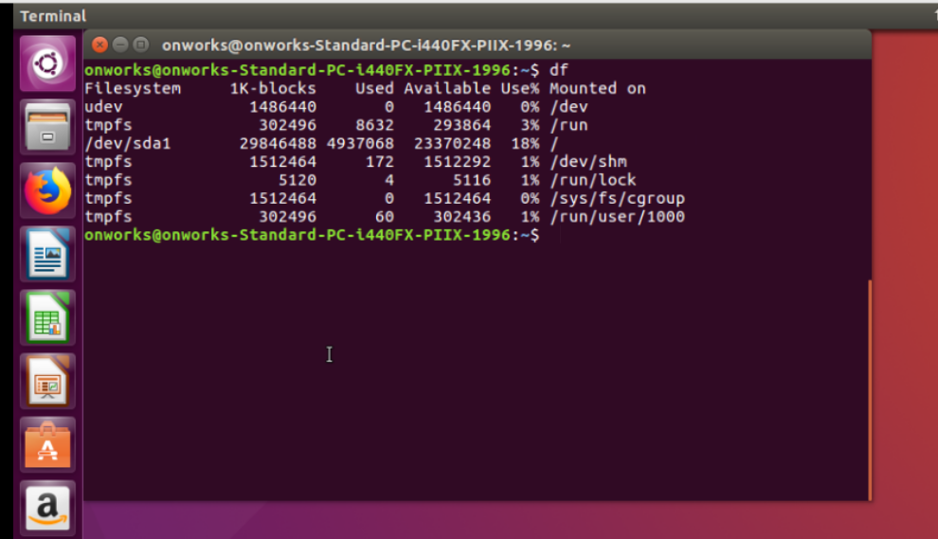

1. df –h : This command is used to display the size in terms of MB or GB.

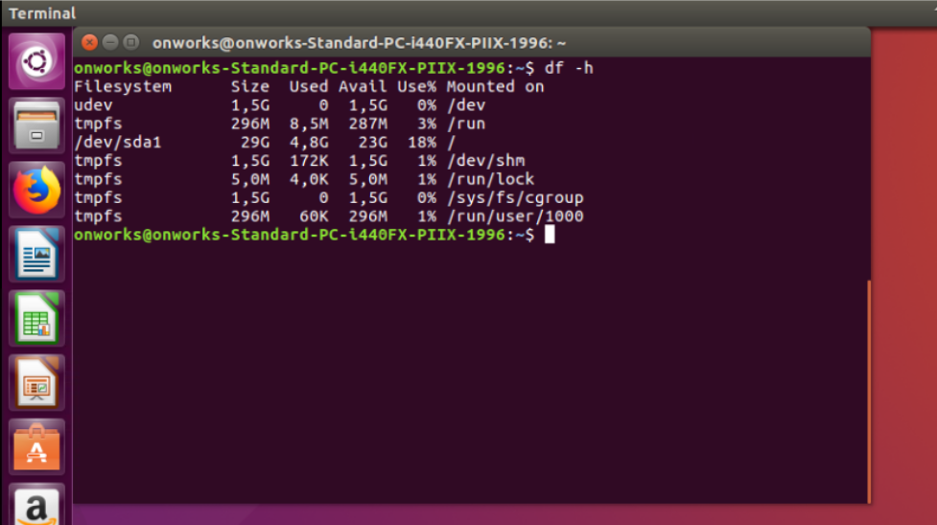

1. ps: This command is used to display the current running process and their PID’s.

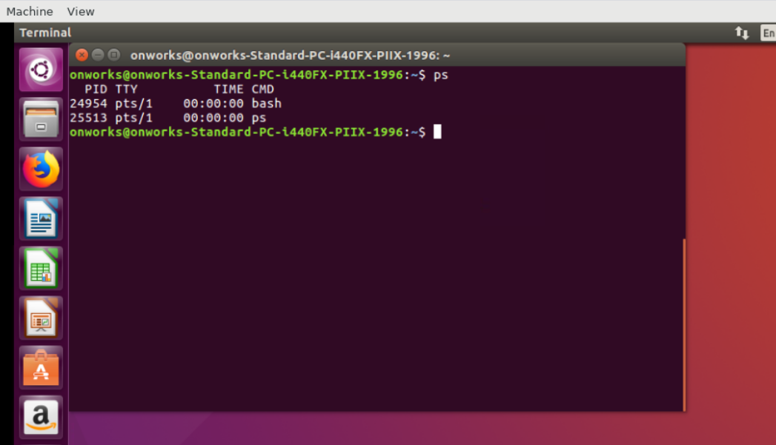

1. ps –a :This is option available with ps command.

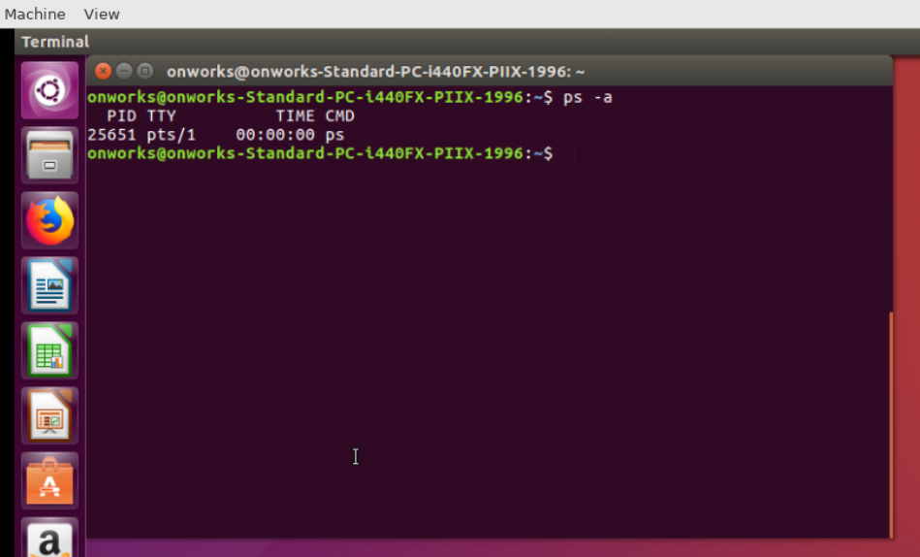

1. su, sudo : To change Super user privilege. This command is used to install new packages.

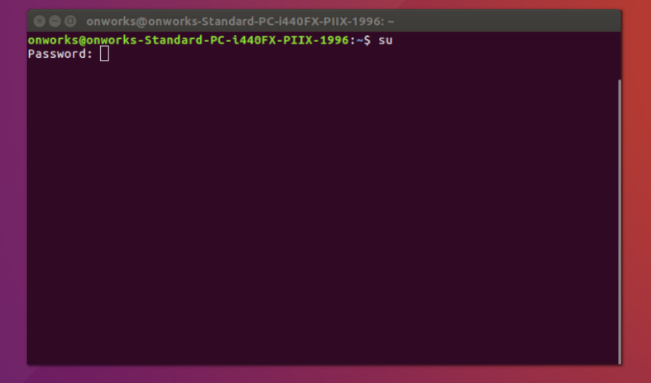

1. Kill: This command is used to kill the process.

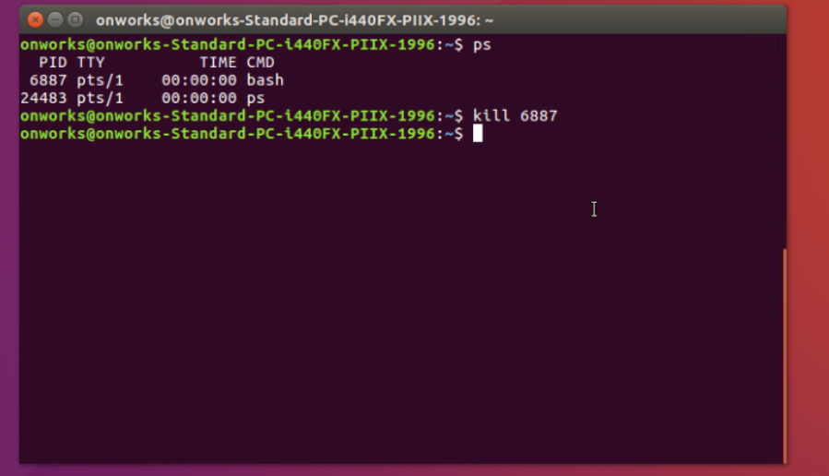

1. free : This command is used to give information about memory usage details.

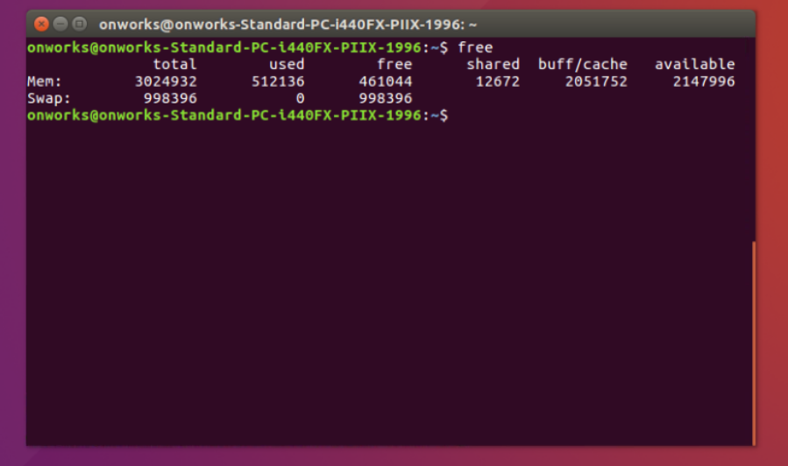

1. Free –h : This command is used to give information about memory usage details in GB or MB.

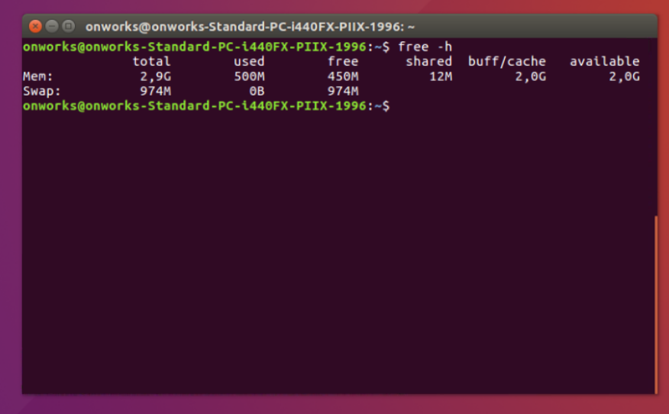

1. echo: To print or display the content on console.

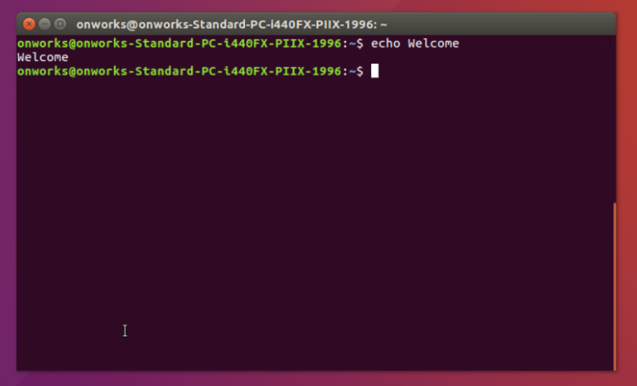

1. top: This command is used to list user and system process.

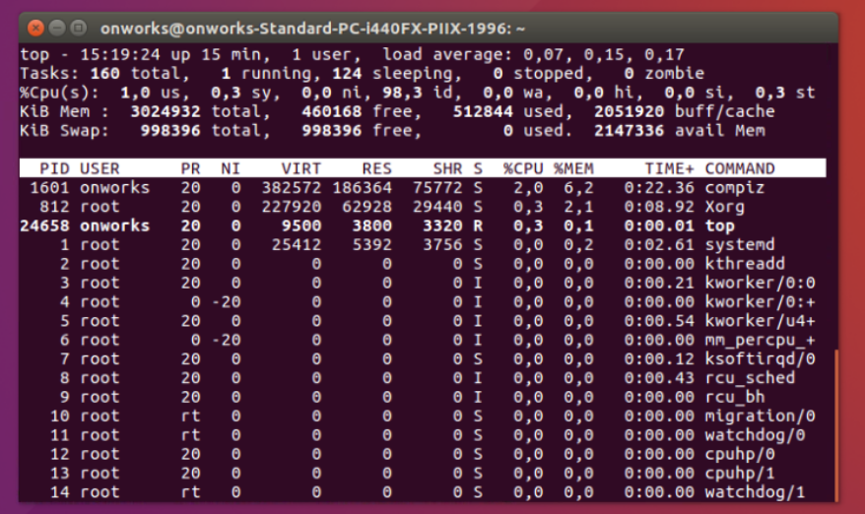

1. lscpu: This command gives information about CPU.

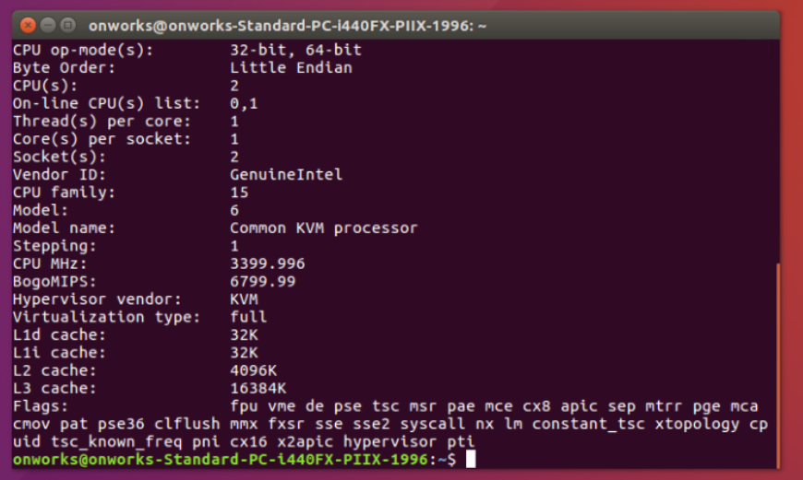

1. lsusb: This command is used to display information about USB buses and devices connected to them.

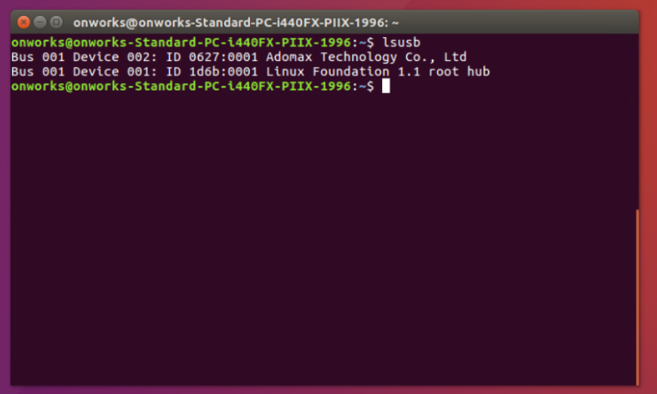

1. lshw: This command is used to list all system configuration.

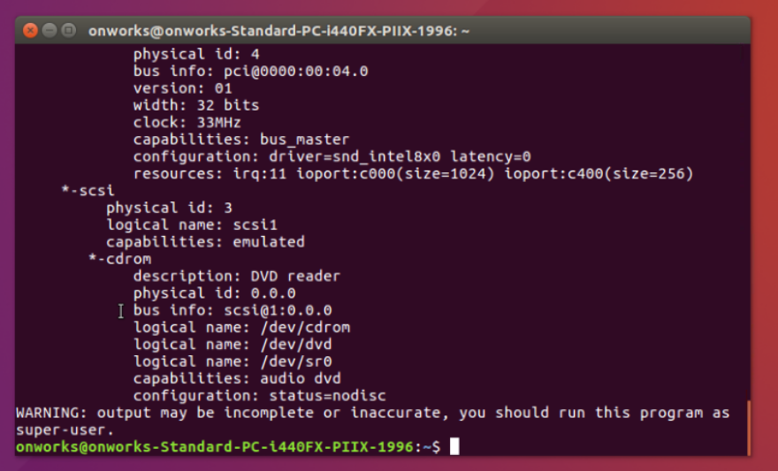

1. vi filename.txt: This command is used to create a new file.

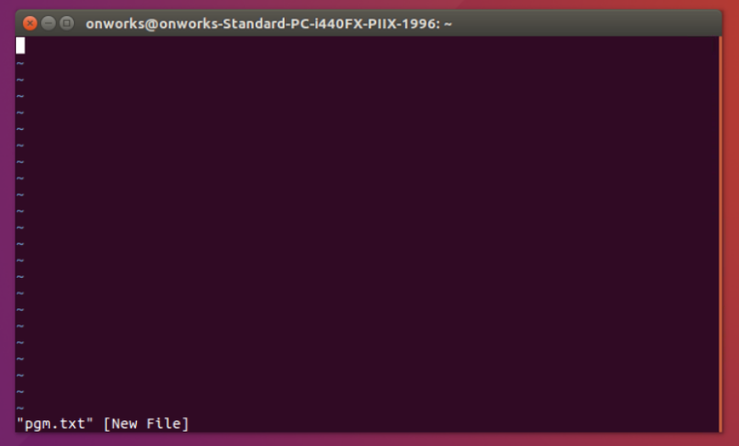

1. cat : This command is used to display the content of the file.

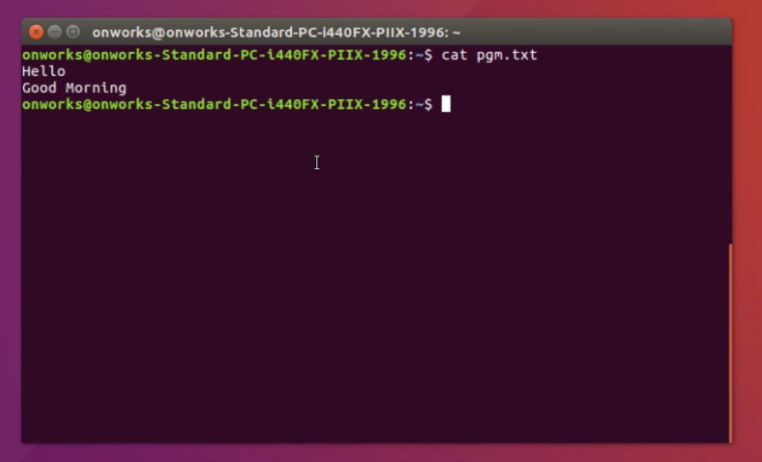

1. cp: This command is used to copy the content from source file to destination file.

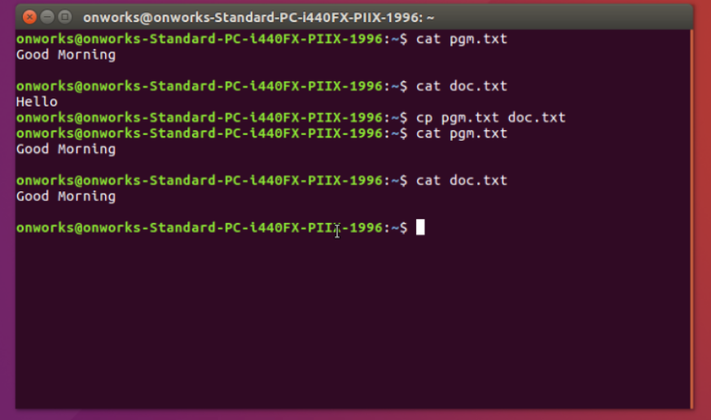

1. mv: This command is used to move the content from source file to destination file.

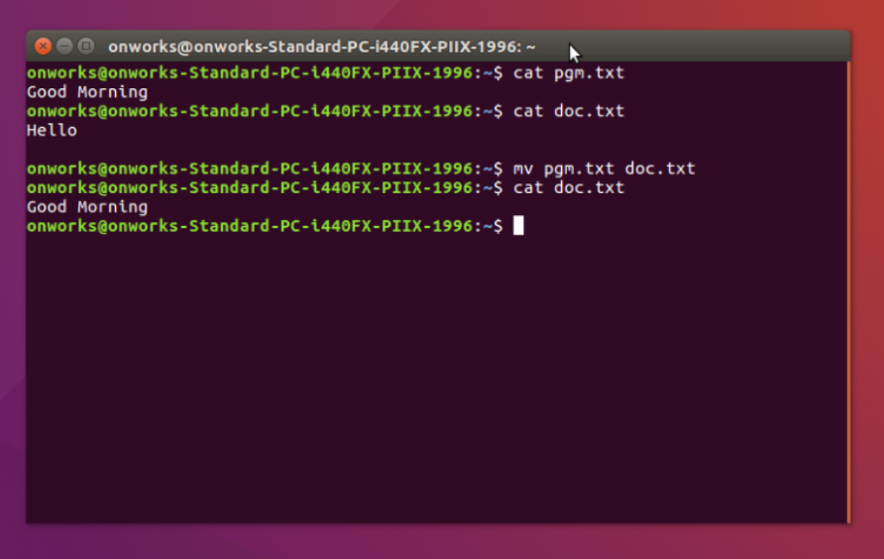

1. vi or vim: Editors terminal. It is programmers text editor.

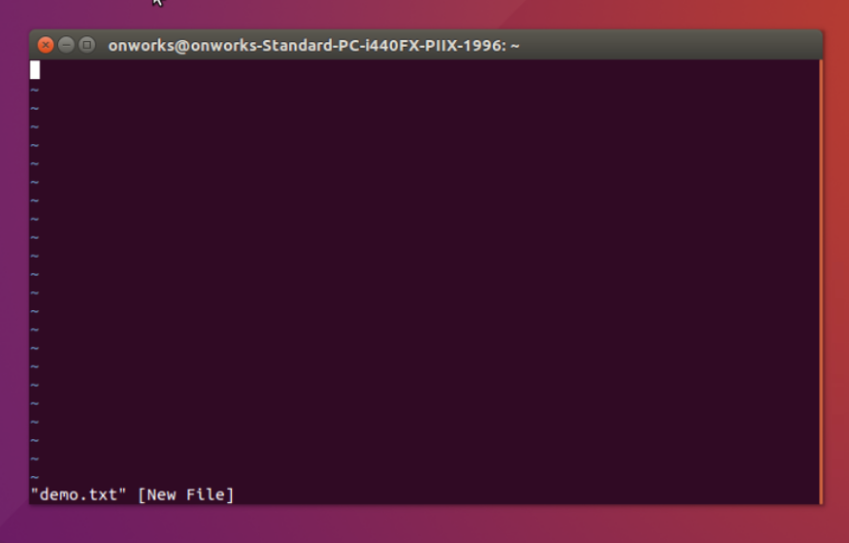

1. dd: This command is used to delete a line.

In this example we have: Hello

Good Morning

How are you

Have a nice day

When we execute dd command to first line the first line gets deleted.

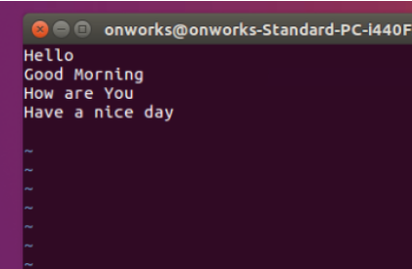 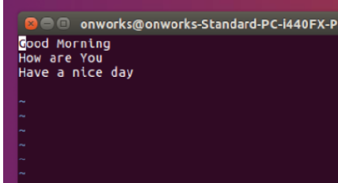

1. dw: This command is used to delete a complete word.

In this example the cursor is at Good, if we execute dw command, it will delete a word Good.

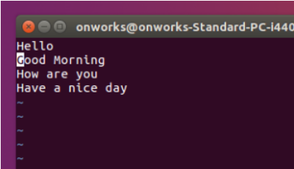 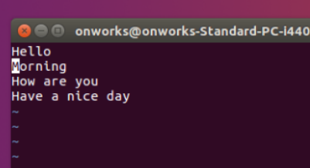

1. x: x command is used to delete single character. In this example the cursor is at H, if we execute x command, it will delete a character H.

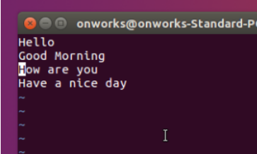 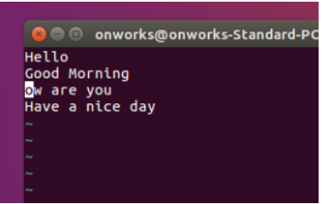

1. yy: This command is used to copy the line.

p: This command is used to paste the line.

In this example Have a nice day is copied and pasted using the command yy and p command.

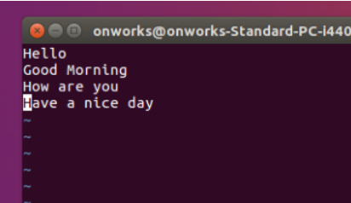 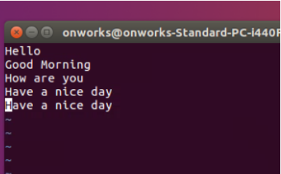

1. grep: This command is used to pattern matching or pattern searching.

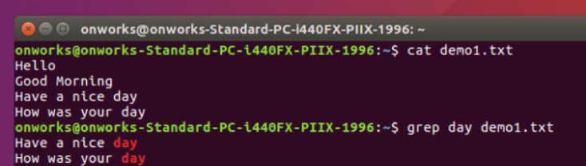

1. head: This command is used to display beginning 10 lines of content of the file.

head –n 2 : is used to display first 2 lines.

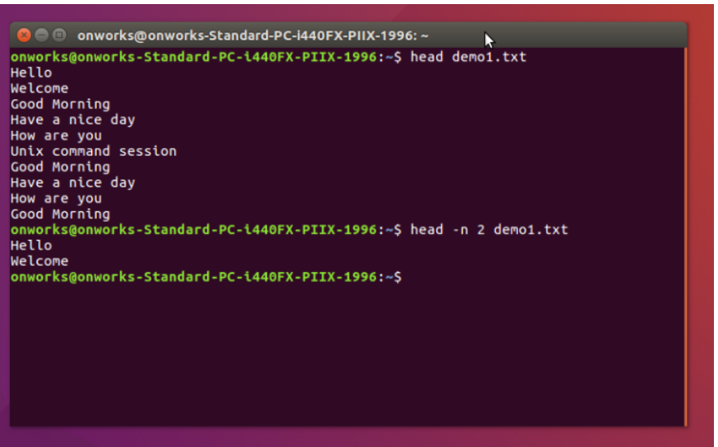

1. tail: This command is used to display last 10 lines content of file.

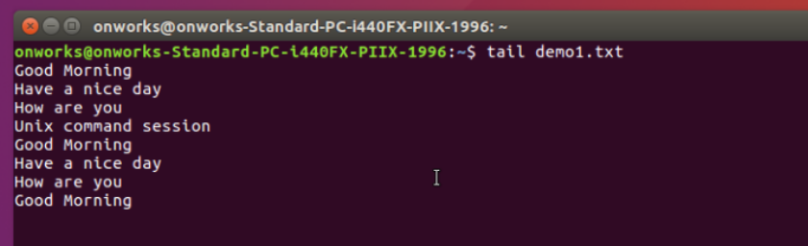

1. uname: This command is used to print system information.

uname: This command is used to print all system information.

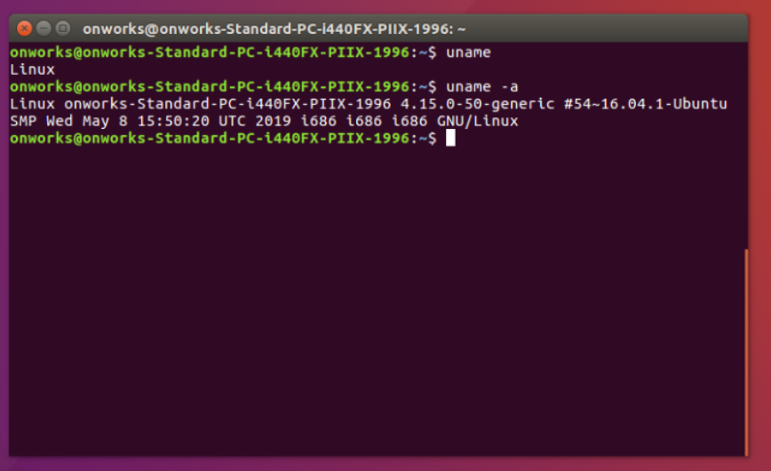

1. ifconfig: This command is used to configure a network interface.

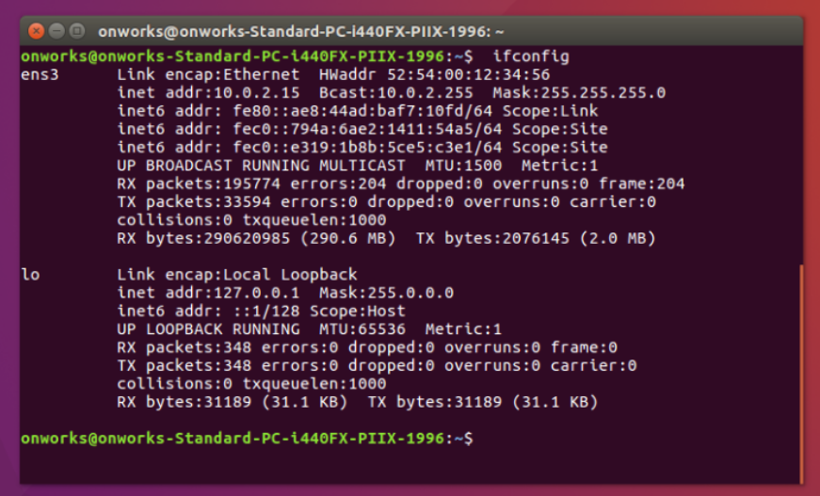

1. hostname: This command is used to display system host name.

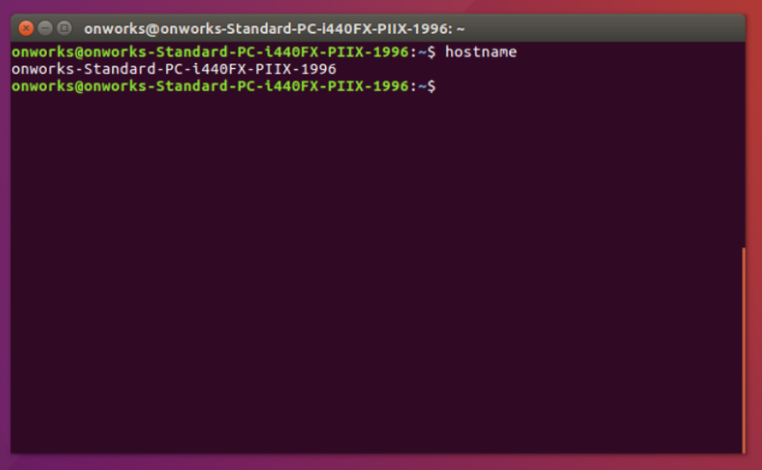

1. who: This command is used to show who is logged on.

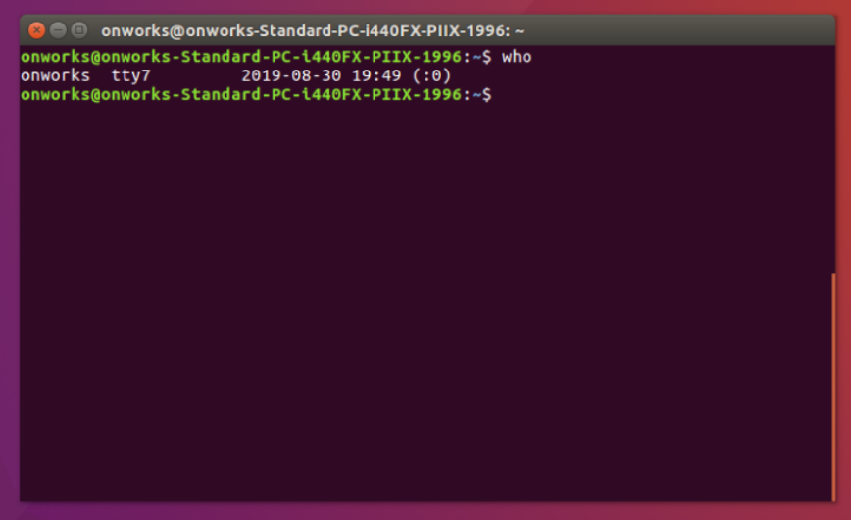

1. whoami: This command is used to print effective user.

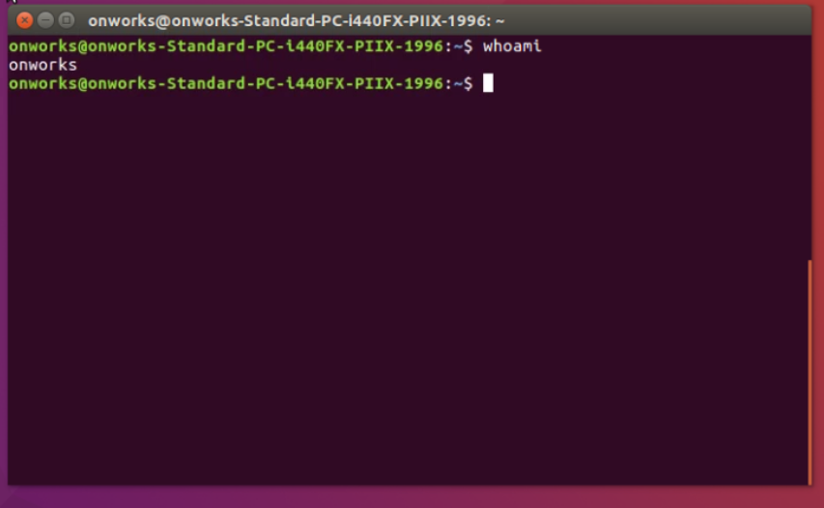

1. tr: This command is used to translate or delete the characters.

In this command when cat command is pipelined with tr –d ‘o’ , it is going to delete all the letters of o.

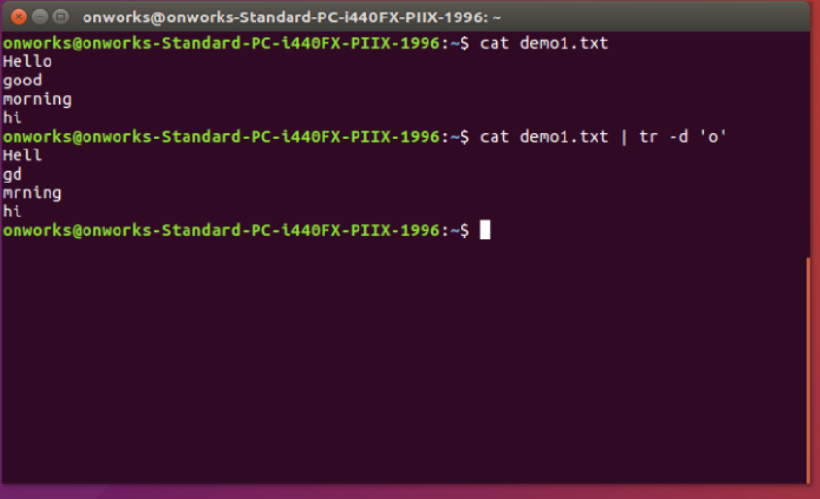

1. find: This command is used to search for files in a directory hiechary.

* find -type f: This command is used to locate files.

